Press Release: Richard Bangs’ Adventures with Purpose
Richard Bangs’ Adventures with Purpose—Greece: Quest for the Gods, a new, one-hour special from American Public Television, will air on _________ (station) _________________ at (time) _______, (day) __________ (date) _________. Hosted by Richard Bangs who is often called “the father of modern adventure travel,” Greece: Quest for the Gods is the latest documentary in a series of adventure travel, eco-conscience, and historical specials. According to Bangs, “Adventures with Purpose not only quicken the pulse and fire the synapses, they are also journeys of enlightenment and discovery—odysseys that make a difference.”
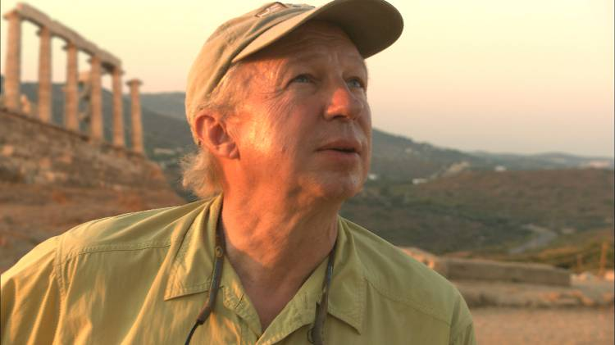
Adventures with Purpose is produced by Small World Productions, the makers of Smart Travels—Europe and Pacific Rim with Rudy Maxa and Travels in Europe with Rick Steves. The specials are co-produced by KCTS/Seattle, and Richard Bangs Productions of Marina del Rey, California. KCTS is the presenting station to APT.

This time Richard Bangs embarks on a great odyssey in Greece, land of the Gods. From the amber of ancient times to the present, the Western world has basked in the glorious inspiration of the Greek myths. These strangely magnificent stories are deeply embedded in our culture and even our collective unconscious. On this trip Richard seeks to discover the relevance and meaning the great gods of Olympus might have for us today.

One modern Greek writer describes the impact and history of ancient Greece’s this way: “In the fifth century before Christ, an unprecedented idea rose from a small Greek city on the dusty plains of Attica and exploded over the Western Hemisphere like the birth of a new sun. Its light has warmed and illuminated us ever since… The vision—the classical Greek idea—was that society functions best if all citizens are equal and free to shape their lives and share in running their state.”

Essential to this revolution of human thought were the gods of Greek mythology. There was a time when the Greek gods were the mightiest and most revered deities in the civilized world. They touched every aspect of life, and influenced every action. Yet, somehow they vanished from our cosmology, leaving behind only temples, ruins and myths… Or did they?

Human beings have always created stories to help explain the world around them. But what was it about the Greek myths that made them so exceptional? Could they have relevance in modern life? If so, how?

To help Richard in his quest for understanding he meets up with author, Agapi Stassinopolous, who has written several books on Greek gods and goddesses.

According to Agapi, “The Gods of the Pantheon are still alive. They are alive in all of us and they are alive in everything you see in Greece. They are the archetypes and they are everywhere—in the land, in the tavernas, in the people talking.” As they tours the country Richard and Agapi search for manifestations of the gods in today’s Greeks, not just in the ruins and temples along the way but in modern life as well.

Richard and Agapi begin in Athens, side-trip to Poseidon’s Temple at Cape Sounion and then head to Olympia, birthplace of the Olympic Games. Their quest takes them on to the island of Ithaca, to the site of mystical oracles at Delphi and finishes at the home of the gods, Mt. Olympus.
Richard Bangs’ Adventures with Purpose
Greece: Quest for the Gods Press Release, Page 2

According to Richard, “It’s hard not to appreciate the glory that was Greece. The culture that pushed the envelope of human reason instigated a revolution in perception and thought. By valuing the unknowable through deities, they discovered the sacredness in human beings. And they laid the foundation for a system of values that respects equality, and balance.”

Bangs concludes that, “We’re still a long way from achieving the five qualities of civilization—truth, beauty, adventure, art and peace, but the garden that was ancient Greece planted the right seeds. And over two thousand years later, it’s time to push the stone of civilization even further: to honor the sacredness in all living things, and assume the responsibility to protect them.”

Adventures with Purpose—Greece: Quest for the Gods is introduced by Arianna Huffington, publisher of the Huffington Post and sister to Agapi Stassinopolous.

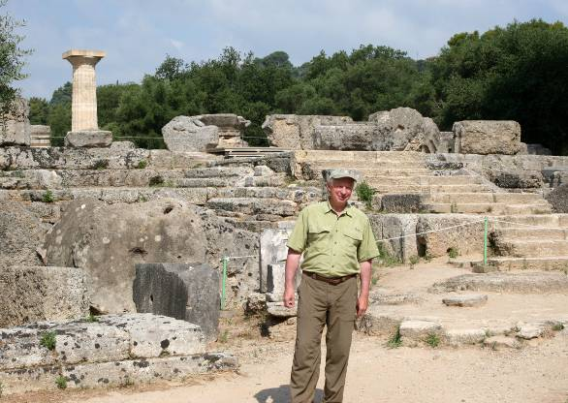
Host and co-executive producer, Richard Bangs is a pioneer in travel that makes a difference, travel with a purpose. He has spent more than 30 years as an explorer and communicator, and along the way led first descents of 35 rivers around the globe, including the Yangtze in China and the Zambezi in Southern Africa. Richard has published more than 1000 magazine articles, 18 books, a score of documentaries and CD-ROMs; and has lectured at the Smithsonian, the National Geographic Society, the Explorers Club and many other notable venues. He writes a semi-regular feature for the NY Times. His latest books include Adventures with Purpose, Quest for Kaitiakitanga, and Quest for the Kasbah, companion books for episodes in the television series.

Richard’s books and DVDs of Adventures with Purpose—Greece: Quest for the Gods are available from Small World Productions. Each DVD contains the complete show and more than two-hours of value-added bonuses: Richard’s adventure travel tales, never-before-seen footage, and behind-the-scenes glimpses. DVDs are $24.95 each plus shipping. Richard’s Adventures with Purpose books are $16.95 each plus shipping. Books include essays by Richard on a number of destinations. A transcript of the Greece show is included with book orders free of charge. The book and DVD together are $35.95 plus shipping. Viewers may order online at www.AdventuresWithPurpose.TV or call the order desk at 800.866.7425.

Small World Productions, Inc. of Seattle produces Richard Bangs’ Adventures with Purpose. KCTS/Seattle and Richard Bangs Productions are co-producers. KCTS is the presenting station. Major support for production and distribution is provided by:
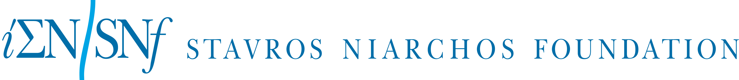

An HDTV version of Adventures with Purpose—Greece: Quest for the Gods will up-link on APT’s HD satellite transponder. The standard definition “letterboxed” version will air on hundreds of public TV stations nationwide. Digital audio is transmitted in stereo.

About American Public Television
With more than 10,000 hours of programming in its library, American Public Television (APT) has been a prime source of programming for the nation’s public television stations for 48 years, distributing more than 300 new titles per year. In 2006, APT launched Create – the TV channel featuring the best of public television's lifestyle programming. Known for its leadership in identifying innovative, worthwhile and viewer-friendly programming, APT has established a tradition of providing public television stations with program choices that strengthen and customize their schedules, such as Rick Steves' Europe, Worldfocus, Globe Trekker, Simply Ming, Sara's Weeknight Meals, America's Test Kitchen From Cook’s Illustrated, Gourmet's Diary of a Foodie, Doc Martin, Lidia's Italy, Rosemary and Thyme, P. Allen Smith's Garden Home, Biz Kid$, Johnny Cash at Folsom Prison, Pavarotti: Salute Petra, The Best of the Jack Benny Show, Agatha Christie's Poirot, Spain...on the road Again, and other prominent documentaries, dramatic series, how-to programs, children’s series and classic movies. For more information about APT’s programs and services, visit APTonline.org.

